***CRF 116422***

**Query for SPL Negative Balance Loan Report Downloading**

select 'Scheme Name',

'Customer Name',

'Loan ID',

'Loan Amount',

'Loan Balance',

'Loan Date',

'Branch Name',

'Loan Status'

from dual

union all

select a."Scheme Name",

a."Customer Name",

to_char(a."Loan ID"),

to_char(a."Loan Amount"),

to_char(a."Loan Balance"),

to_char(a.tra_dt) LoanDate,

to_char(c.branch_name),

decode(b.status_id,

0,

'Settled',

1,

'Live',

7,

'Cancelled',

'UnKnown')

from mana0809.view_nloan_disb_rpt_all a,

mana0809.branch_master c,

mana0809.state_master d,

mana0809.district_master e,

mana0809.tbl_nloan_product_master a1,

mana0809.tbl_nloan_loan_mst b

left outer join (select f.doc_id, to_char(min(f.value_date)) value_date

from mana0809.payment_master f

group by f.doc_id) fg

on fg.doc_id = b.loan_id

left join mana0809.tbl_nloan_application m

on m.loan_id = b.loan_id

left join mana0809.employee_master k

on k.emp_code = m.approved_by

left join mana0809.LG_LC_Status lg

on lg.loan_id = b.loan_id

where a.loan_id = b.loan_id

and b.branch_id = c.BRANCH_ID

and c.state_id = d.state_id

and e.district_id = c.district_id

and a.PRODUCT_ID = a1.product_id

and a1.dept_id = '637'

and a."Loan Balance" < '0'

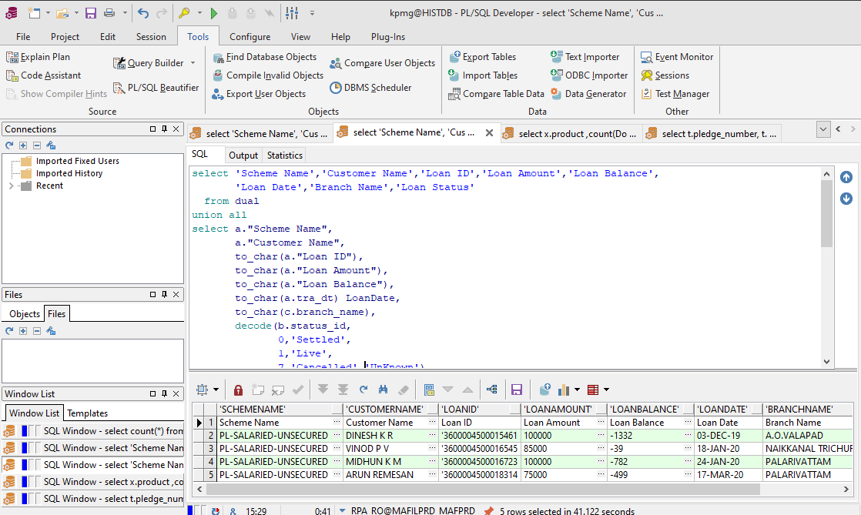

**Excel Format**

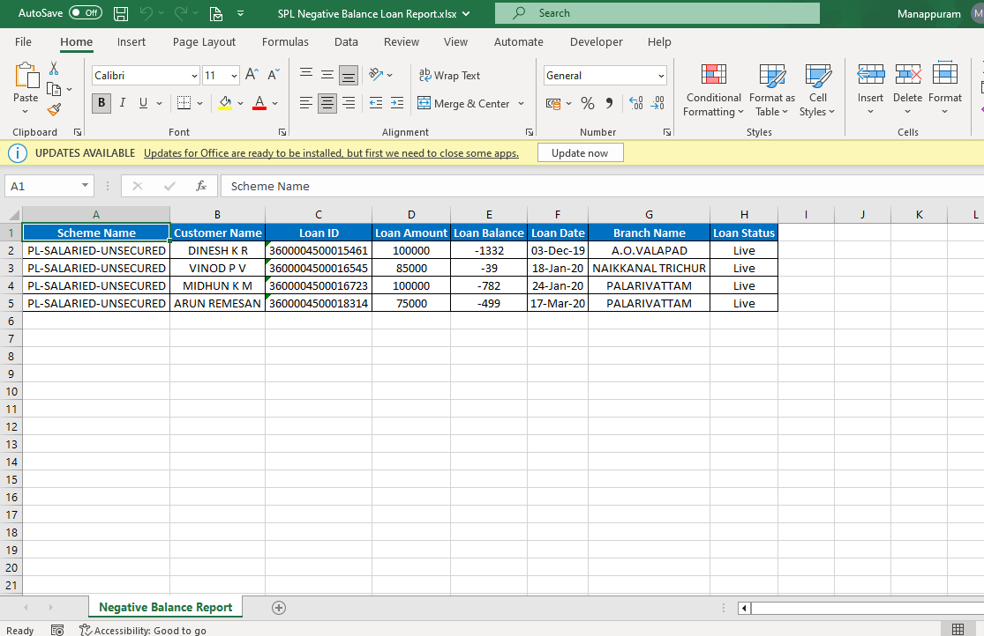

**Mail**

